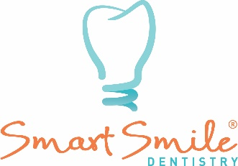

**Terms and Conditions (Terms of Service)**

**Effective Date:** 10/02/2025

By opting in to receive SMS messages from Smart Smile Dentistry (“we,” “us,” “our”), you agree to the following terms:

**1. SMS Messaging Service**

By providing my phone number, I consent to receive SMS text messages from Smart Smile Dentistry for appointment reminders, marketing messages, and general two-way communication. Msg frequency varies. Msg & data rates may apply. Reply HELP for support. Reply STOP to opt out.

**2. Message Frequency**

You will receive up to 4 text messages during the month you are scheduled for an appointment

**3. Message and Data Rates**

Message and data rates may apply based on your mobile carrier’s terms.

**4. Privacy Policy**

Your information will be handled in accordance with our Privacy Policy, which can be viewed at https://www.smartsmiledentistry.com/new-patients/

**5. Opt-Out Instructions**

You can opt out at any time by replying “STOP” to any SMS message. Reply HELP for support. You may also contact us directly at (352) 376-5120.

**6. Liability**

We are not responsible for any charges, errors, or delays in SMS delivery caused by your carrier or third-party service providers. By opting in, you confirm that you are the owner or authorized user of the phone number provided and that you are at least 18 years old.